**Project: Simulation of chromosomal organization in Yeast**

**O. Shukroun**

**Coordinator: A. Taddei and D. Holcman**

**Summary of the project:**

We propose here to design numerical simulations of chromosomes in yeast and in particular to study the clustering of telomeres based on SIR3 affinity and information about the CC-map of the organization of chromosomes. The CC- interpretation is based on Ofir’s previous analysis, which allows the construction of Rouse polymer, with looping and local interactions.

**Aim**: In this work, we propose to demonstrate that a telomere hypercluster in Yeast nucleus can be explained by the stochastic motion of the chromosomes’ arms in yeast nucleus, governed by the physical rules of polymer physics and association and dissociation of the telomeres.

**Background**: Hyper-clusters of telomeres in the yeast cells are formed in a wild-type under quiescent condition and SIR3 overexpression. If hyperclustering under SIR 3 overexpression is understood (Hoze, 2013), it is not the case in quiescent conditions.

In addition, the mechanical mechanism of polymer causing clustering is yet to be elucidated. Yeasts’ chromosomes, encored at the nucleus membrane allow the motion of the two arms of the chromosomes, and its telomeres can associate and dissociate to form cluster. How can a hypercluster of telomeres form? We shall address this question using stochastic simulations of chromosomes.

**Hypothesis to be checked:** preventing telomeres to be attached to the surface of the nucleus is sufficient to generate a stable hypercluster inside the nucleus. We will estimate the mean size of this hypercluster and the residence time of two telomeres in such hypercluster, following the principles described in Hoze et al MBC 2013.

**Methods**: Using the polymer dynamics simulation framework, we have previously constructed, we will reconstruct and simulate the motion of chromosomes arms inside a spherical nucleus domain. All chromosomes will be encored on the nuclear surface (Fig. 1 A &B) and the chromosome arms will be modeled as Rouse chains.

Telomeres of different chromosomes are allowed to associate with an association constant *ka* , obtained from the stochastic simulations. Two telomeres bind when two of their SIR3 interact at a distance d (defined by the geometry of the SIR 3 complex). The dissociate constant *kd at* a distance *d* is defined by the SIR3 biochemistry. We will account for the cross structure organization of the SIR 3 on the telomere. The stability of two telomeres together will be evaluated numerically and depends on the number of SIR3 complex interacting domains.

We will estimate the stability of clusters (Fig. 1 B) using numerical simulations. Association of chromosome are in the telomeric regions and depend on the size the region covered by SIR3. We will be predefined this region at the end of the chromosome (Fig. 1C).

We will evaluate from numerical simulations the statistical properties of a hyper cluster and we will compute the probability to form clusters of telomeres of variables sizes and the encounter probability between different parts of the chromosome arms while clustered.

**We need the following data:**

1-the length of all chromosomes.

2-position of the centromeres

3-the number of SIR3 per chromosome

4-the size of the SIR3, the chemical afinity, the local distance between two consecutive SIR3 domains

5-the CC-map of short and a long chromosomes.

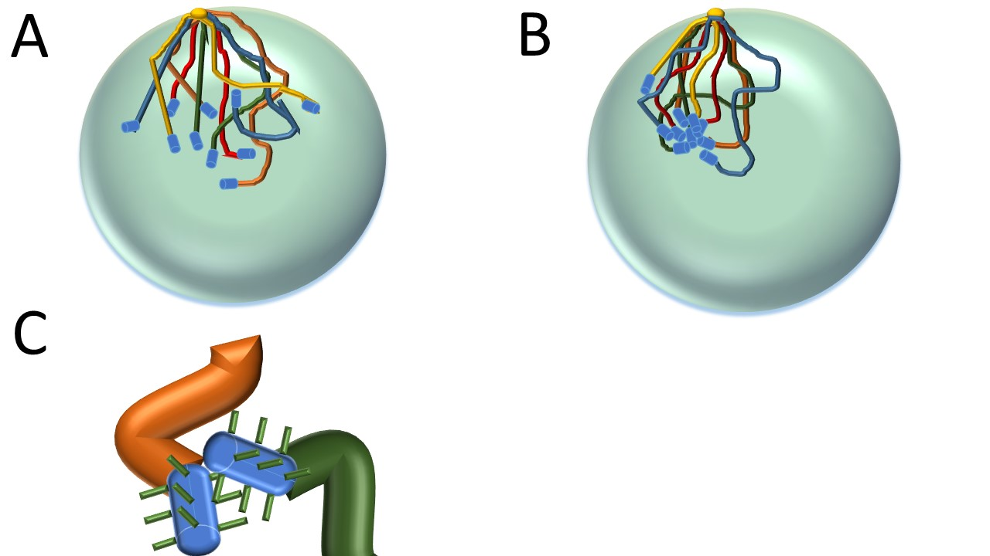

**Figure 1.** A: schematic representation of the chromosomes in a spherical domain, all chromosomes will be encored at one point (yellow sphere) and their arms will undergo stochastic motion following an adapted Rouse chain dynamics. A cluster of telomeres can be formed when telomeres encounter each another at a distance d (B). Only the ends of the chromosomes are allowed to bind where Sir 3 are located. (C): representation of the binding area at the telomere.